# Guidelines for the use of the FDA/PhUSE Script Repository

(1/15/2013 Version 1.0)

## Introduction

This repository is for storing standard scripts identified, developed and shared by volunteers who are interested in data transformations and analyses across and/or within a therapeutic area and exploratory analysis. The goal will be to begin the process of standardizing analyses across the industry, but also include examples of what can be done with a standardized data set. This will be a collaborative environment by using Google Code and online wiki to create and add scripts and documents that can be shared openly between industry entities and regulatory agencies.

## How to get involved

1. Join PhUSE as a member and receive regular email updates and participate in a variety of events
2. Sign up for the PhUSE working group mailings
   1. Go to [www.listbox.com](http://www.listbox.com)
   2. Join this group: “CSS WG5: Developing Standard Scripts”
3. Sign up to be a contributor in the script repository
   1. Send an email to [HTu@OCTAGONRESEARCH.com](mailto:HTu@OCTAGONRESEARCH.com) (or [hanming.h.tu@accenture.com](mailto:hanming.h.tu@accenture.com)) requesting to join the Google Code PhUSE/FDA script repository
   2. Go to repository at <https://code.google.com/p/phuse-scripts/> and start interacting

## What role you want to play?

In Google code, there are two roles that a person can play:

* Committer: may work in the project, but may not reconfigure it. In FDA/PhUSE project, a committer shall take some duties in the repository and shall take ownership for at least one script and shall guide and recruit developers to develop the script and document milestones of the script advancements.

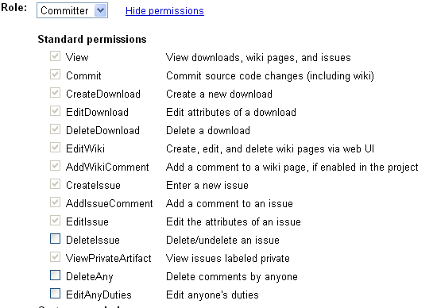

* Contributor: start with the same permissions as non-members, but their role in the project is visible. A contributor shall take at least one duty in the repository and may participate at development of a script.

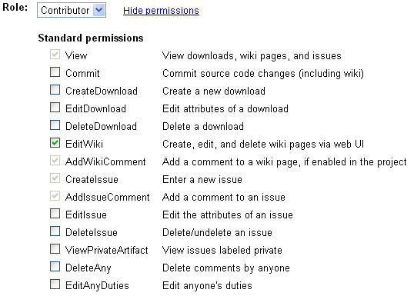

Usually, only Committers may add new scripts. If you are a contributor, you can request to have edit privileges by emailing [HTu@OCTAGONRESEARCH.com](mailto:HTu@OCTAGONRESEARCH.com) (or [hanming.h.tu@accenture.com](mailto:hanming.h.tu@accenture.com)).

## How to add a new script

You have two methods to add a script: 1) using browser or 2) using subversion client tool such as TortoiseSVN.

In the [repository](https://code.google.com/p/phuse-scripts/source), go to the sources tab and navigate to the appropriate directory. The directories are organised by scripting language (e.g. R/SAS) and then into analytical or functional areas. Inside each functional area (e.g. the DM directory for demographic scripts), there are 6 directories:

* baks: backup and old versions
* data: example or test data files
* docs: documentation
* result: any outputs files
* src: source code
* valid: validation files

For more information about the folder structure, please review this file: <http://code.google.com/p/phuse-scripts/source/browse/trunk/folder_structure_proposed.txt>.

Users are encouraged to add documentation when adding a script. There are template documents for User Guides and Specifications documents here (link to be added), and it is strongly encouraged to utilise these documents for new scripts and to follow the recommended name conventions.

Committers will add scripts or packages of scripts as “Downloads” as appropriate. “Downloads” are easily accessible packages of code that can be downloaded by anyone.

## *Add script through browser*

Here are the steps for adding a script through a browser:

1. go to the FDA/Script repository: <http://code.google.com/p/phuse-scripts/>
2. Click Source🡪 Browse🡪trunk and expand to the folder that you’d like to add a script
3. Click “Create” or “Upload” to upload a ready prepared script.
4. If you choose “Create”, a simple window with line numbered text editor is opened
5. Provide and append a file name in the path field
6. Provide description in the commit log field
7. Click the “Commit” button.

Caution: if you have not done step 7, your change will not be saved!

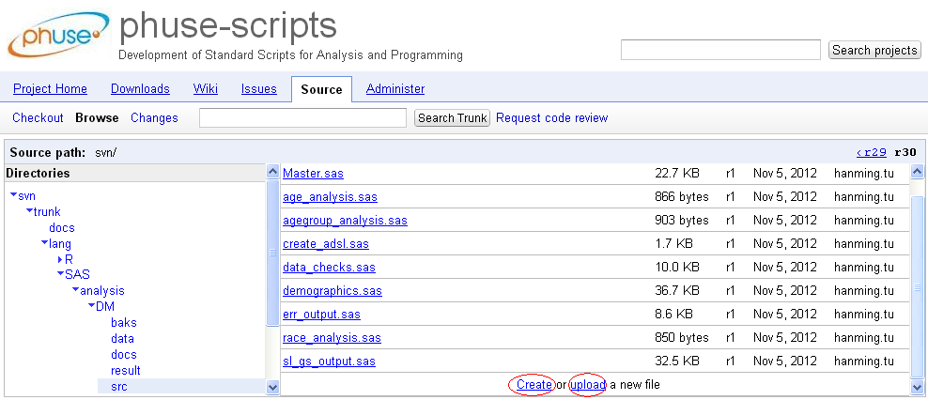

## *Add script through TortoiseSVN*

Here are the steps:

1. Install TortoiseSVN by following the links listed in <http://code.google.com/p/phuse-scripts/wiki/ReadMeFirst> or the steps in this file <http://www.prosvn.org/download/TortoiseSVN%20-%20Installation%20EN.pdf>
2. Once you have installed the subversion client, you can check out the whole repository by following the instruction at <http://code.google.com/p/phuse-scripts/source/checkout>
3. Once you have the repository at your local drive, you can navigate to the folder in the local repository and just copy your script to the folder
4. Then right-click on the folder, then click the “SVN Commit”

|  |  |
| --- | --- |
|  |  |

## How to edit a script

Only contributors or committers with added edit privileges can edit scripts.

The FDA/PhUSE script repository uses a Subversion repository to manage version control. Further information can be found here: <http://subversion.apache.org>. It is recommended that you use a package to manage Subversion with your operating system. A list can be found by [clicking here](http://subversion.apache.org/packages.html). For Windows users, there is some experience in the group with the Tortoise SVN package that can be downloaded [here](http://tortoisesvn.net/downloads.html) (be careful not to click on the download buttons that appear in adverts on the page).

Scripts can be edited directly from the Google code webpage, or via a Subversion package installed on your local computer.

Committers can raise an issue with a script to highlight the need for an edit by following the instructions below.

## How to flag an issue with a script

Go to the “Issues” tab of the Google Code repository and click the new issue button, completing the details on the displayed form.